ACADEMIC YEAR: 2024--2025

LEVEL: YEAR2(A,B,C,D) TERM: ……I…….. Date: 7 November 2024

CAT

DATA STRUCTURES AND ALGORITHMS USING C++

Timing: 180 minutes

Maximum:100 Marks

Instructions:
- The test is written
- Follow the guidelines provided and seek clarifications if need be.
- Attempt all Questions of Section A, 3 of Section B and 1 of Section C.
- The test is closed to any resource material.
- Collaboration and any kind or cheating is prohibited and should be resulted into a GOOD ZERO.

INSTRUCTORS
HABANABASHAKA Jean Damascene
HATANGIMBABAZI Hilaire

SECTION A: Attempts all Questions: Each Question worth 2 Marks
- A C program is a C++ program when compiled and executed as a C++ program.
a)Yes
b)No
- C++ is an extension of C Programming language
- Yes
- No
- The namespace is a feature available in C and C++.
- Yes
- No
- The following C++ statement
scanf(“%d %d”,&a,&b);
Can be rewritten in C++ as below:
cin<<a<<b;
a)Yes
b)No
- An algorithm is a set of instructors to solve a problem.
- Yes
- No
- Data Structure is a logical or mathematical model for collecting and organising data in such a way that we can perform operations on these data in an effective way.
- Yes
- No
7. Which of the following is a feature of Object-Oriented Programming?
A) Encapsulation
B) Inheritance
C) Polymorphism
D) All of the above
8. What is encapsulation?
A) Binding data and methods together
B) Hiding details from users
C) Making classes inherit from each other
D) None of the above
9. In C++, which operator is used to access members of a class or struct?
A) ::
B) ->
C) .
D) :
Note: Based on Object creation both 2 are valid
10. Variables names num1 and NUM1 are the same in C++.
- Yes
- No
11. Which of the following is true about constructors?
A) They do not have a return type
B) They are automatically called when an object is created
C) They can be overloaded
D) All of the above
12. In C++, the following is allowed for a class Person
Person p=new Person();
- Yes
- No
13. What is a destructor used for?
A) Allocating memory
B) Initializing object values
C) Cleaning up when an object goes out of scope
D) Setting default values

14. Namespace declarations don’t have access specifiers
- Yes
- No
15. Choose the correct answer. The constant PI can be defined in C++ like:
- #define PI=3.14
- #define PI 3.14;
- #define double PI=3.14
- #define PI 3.14
- None of the above
16. Indicates the output of the following formatting statements in highlights:
int a=191;
cout<<hex<<a<<endl;
- BC
- BD
- FB
- DF
- BF
- None of the above
17. Indicates the value of k as output of the following formatting statements in highlights:
int a=191;
int k=a>>3;
cout<<k<<endl;
- 63
- 48
- 23
- 95
- 382
- None of the above
18. Indicates the value of k as the output of the following formatting statements in highlights:
int a=91;
int k=a<<3;
cout<<k<<endl;
- 273
- 94
- 728
- 88
- None of the above
19. What is the output of the following C++ program if the user input 2 and 6 for v1 and v2 respectively:
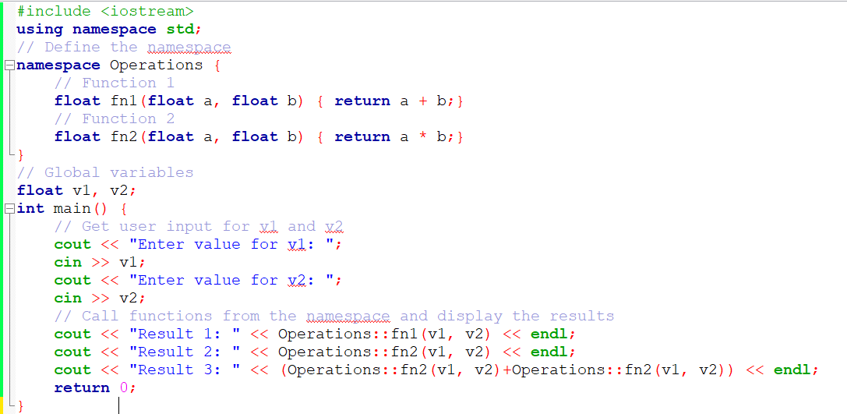
- Result 1: 2
Result 2: 6
Result 3: 8
- Result 1: 8
Result 2: 12
Result 3: 24
- Result 1: 8
Result 2: 12
Result 3: 20
- None of the above

20. Provide the name of the following highlighted operator
::
- Insertion Operator
- Section operator
- Scope operator
- Scope resolution operator
- None of the above

21. What is the output of the following C++ program if the user input 7 for n?
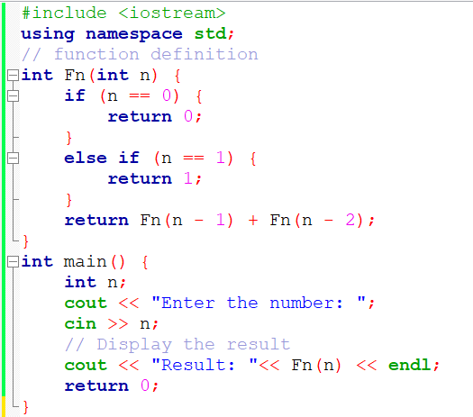
- Result: 13
- Result: 7
- Result: 15
- None of the above
23. Which of the following keywords is used to define an object?
A) struct
B) object
C) class
D) None of the above
24. How many destructors can a class have?
A) 1
B) 2
C) Any number
D) None
25. Which type of inheritance is used when a class inherits from multiple classes?
A) Multiple Inheritance
B) Multilevel Inheritance
C) Hierarchical Inheritance
D) Hybrid Inheritance

SECTION B: Choose 3 Questions only. Each Question worth 10 Marks

26. Build a C++ program with a function using a template to develop a function with name multiply that returns the product of two numbers. Two numbers can be integers or double or short or float. Add a main method and call two times the method multiply on different types of numbers. /10 Marks

27. Using recursion, develop a function that counts the occurrence of a digit in a given number. The signature is provided below.
int countOccurrence(int number, int digit)./10 Marks

28. Make the class Person(id, name and age) in C++. Encapsulate the class and in the main method create two objects using different instantiation techniques/methods. Use cout to print the details of each Person Created./10 Marks

29. Write a C++ program implementing the algorithm to find the second smallest digit in a given positive integer.
The signature is int findSecondSmallest(int number)
For example findSecondSmallest(37458) would return 4. /10 Marks

30. Define a function findBiggestDigit() in a C++ program which receives an integer number and returns the biggest among its digits.
The signature is findBiggestDigit(int number).
For example, findBiggestDigit(76390) will return 9. /10 Marks
}

SECTION C: Attempt only one. /20 Marks
31. An array with an odd number of elements is said to be centered if all elements (except the middle one) are strictly greater than the value of the middle element. Note that only arrays with an odd number of elements have a middle element. Write a function that accepts an integer array and array size and returns 1 if it is a centered array, otherwise it returns 0.
The function signature is: int isCentered(int arr[], int size);
Examples
If the input array is | Then the function returns
{1, 2, 3, 4, 5} | 0 (the middle element 3 is not strictly less than all others)
{3, 2, 1, 4, 5} | 1 (the middle element 1 is strictly less than all other elements)
{3, 2, 1, 4, 1} | 0 (the middle element 1 is not strictly less than all others)
{1, 2, 3, 4} | 0 (no middle element)
{} | 0 (no middle element)

32. Write a function to return an array containing all elements common to two given arrays containing distinct positive integers. You should not use any inbuilt methods. You are allowed to use any number of arrays.
The signature of the function is:
Examples
if input parameters are | return
{1, 8, 3, 2}, {4, 2, 6, 1} | {1, 2}
{1, 8, 3, 2, 6}, {2, 6, 1} | {2, 6, 1}
{1, 3, 7, 9}, {7, 1, 9, 3} | {1, 3, 7, 9}
{1, 2}, {3, 4} | {}
{}, {1, 2, 3} | {}
{1, 2}, {}
{1, 2}, null | null
null, {} | null
null, null | null

DSA EXAM TERM 1

